***High Level Design – Interview Scheduling System***

**Created by:** Team Alpha

**Version:** 2.0.0

**Date:** 21-04-2022

**Table of Contents**

**1. Introduction** **iii**

**2. System Architecture** **v**

**3. Database Diagram** **xiii**

**4. Database Dictionary** **xv**

**5. Services** **xvii**

**6. Modification History** **xviii**

# **Introduction**

This document provides a detailed design of the system. It starts with the design principle used, lists the non-functional requirements and a detail description about the subsystem or components which comprise the system and their interactions.

# **System Architecture**

The Interview Scheduling System can be divided into the following subsystems.

* + A subsystem for logging in, create a new user, edit the details etc.
  + The Interview Scheduling system which can provide access for interviewer, schedule drive, cancel drive, create pools, manage pools, view statistics of interviewers.

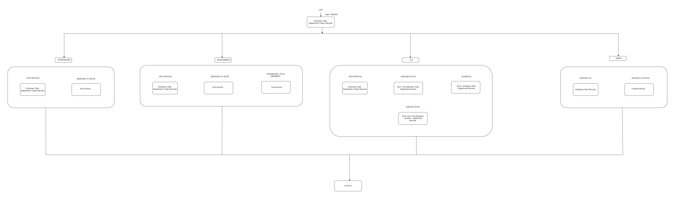

# **Database Diagram**

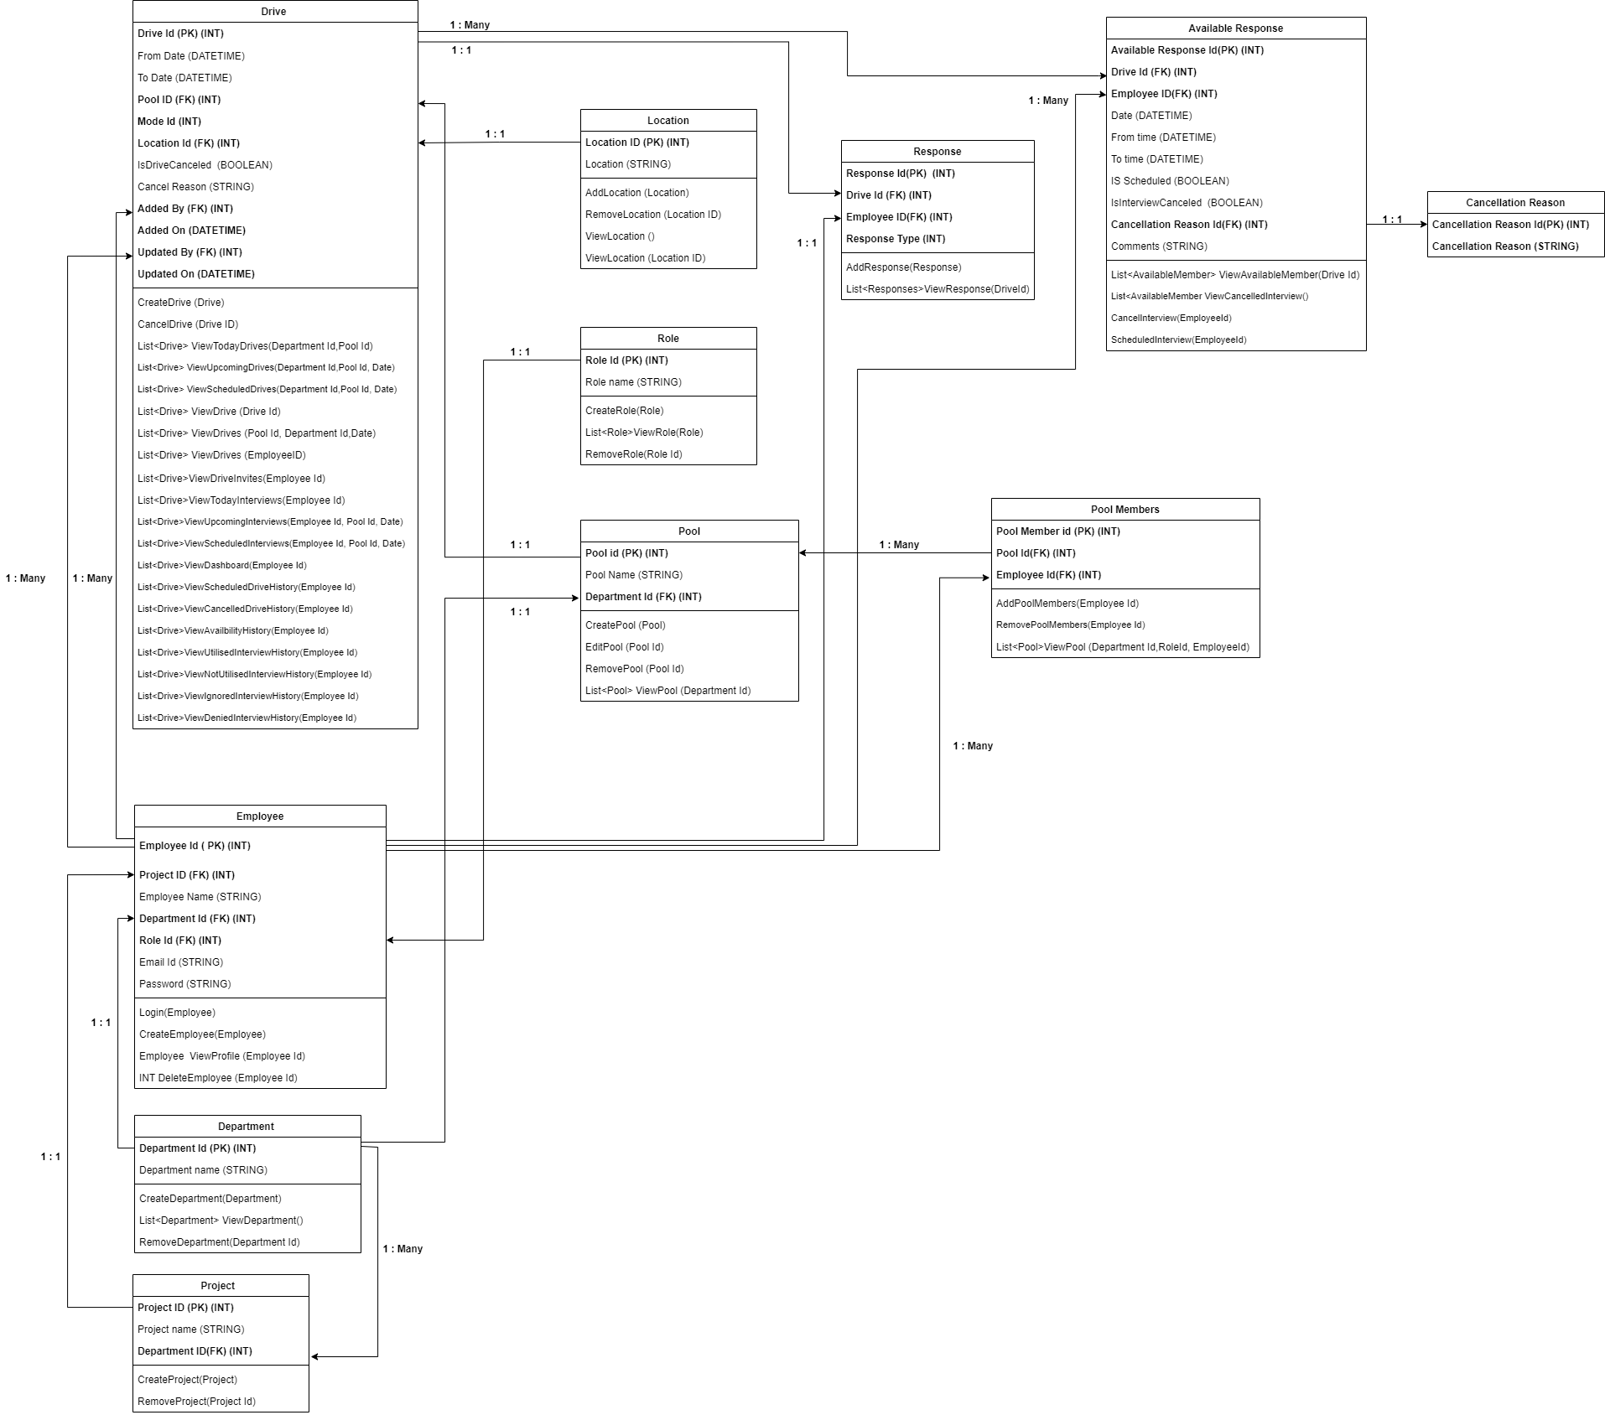

A subsystem for logging in,

# **Database Dictionary**

**Table 1. DRIVE**

|  |  |  |  |
| --- | --- | --- | --- |
| **Field Name** | **Data type** | **Constraints** | **Description** |
| Drive ID | integer | Primary key | ID for each Drive |
| From Date | Int | Not null | Beginning date of Drive |
| To Date | Int | Not null | End date of Drive |
| Pool ID | Int | Foreign Key | ID for each Pool |
| Role | nVarchar (20) | Not null | Role of an Employee |
| Mode ID | Int | Foreign Key | ID for each Mode |
| Location ID | Int | Foreign Key | ID for each Location |
| Added by | Int | Foreign Key | Name of the Created person the drive |
| Added on | DateTime | Not null | Date & Time of the drive |
| Updated by | Int | Foreign Key | Name of the person updated the drive |
| Updated on | DateTime | - | Updated Date & Time of the drive |
| Is Drive Cancelled | Bool | Not null | Flag to Find drive status |
| Cancel Reason | nVarchar (500) | - | Reason for Cancellation of Drive |

**Table 2. POOL**

|  |  |  |  |
| --- | --- | --- | --- |
| **Field** | **Data type** | **Constraints** | **Description** |
| Pool ID | integer | Primary key | ID of the Pool |
| Pool Name | nvarchar (50) | Not Null | Name of Pool |
| Department ID | Int | Not null | ID of the Department |

**Table 3. DEPARTMENT**

|  |  |  |  |
| --- | --- | --- | --- |
| **Field** | **Datatype** | **Constraints** | **Description** |
| Department ID | Int | Primary key | ID of each Department |
| Department Name | nvarchar (50) | Not null | Name of department |

**Table 4. ROLE**

|  |  |  |  |
| --- | --- | --- | --- |
| **Field** | **Datatype** | **Constraints** | **Description** |
| Role ID | Int | Primary key | ID of each Role |
| Role Name | nvarchar (50) | Not null | Name of Role |

**Table 5. EMPLOYEE**

|  |  |  |  |
| --- | --- | --- | --- |
| **Field** | **Datatype** | **Constraints** | **Description** |
| Employee ID | Int | Primary Key | ID for each Employee |
| Employee Name | nvarchar (30) | Not null | Name of Each Employee |
| Department ID | Int | Foreign Key | ID of each Department |
| Role ID | Int | Foreign Key | ID of each Role |
| Email ID | nvarchar() | Not null | Email ID of Each Employee |
| Password | nvarchar() | Not null (Minimum 8) | Not null |

**Table 6. PROJECT**

|  |  |  |  |
| --- | --- | --- | --- |
| **Field** | **Datatype** | **Constraints** | **Description** |
| Project ID | Int | Primary Key | ID for each project |
| Project Name | varchar (50) | Not null | Name of each project |
| Department ID | Int | Foreign Key | ID of each Department |

**Table 7. LOCATION**

|  |  |  |  |
| --- | --- | --- | --- |
| **Field** | **Datatype** | **Constraints** | **Description** |
| Location ID | Int | Primary key | ID of each Location |
| Location | nvarchar (50) | Not null | Name of Location |

**Table 8. POOL MEMBERS**

|  |  |  |  |
| --- | --- | --- | --- |
| **Field** | **Data type** | **Constraints** | **Description** |
| Pool Member ID | Int | Primary key | ID of the Pool Member |
| Pool ID | Int | Foreign Key | ID of each Pool |
| Employee ID | Int | Foreign Key | ID for each Employee |

**Table 9. RESPONSE**

|  |  |  |  |
| --- | --- | --- | --- |
| **Field** | **Data type** | **Constraints** | **Description** |
| Response ID | Int | Primary key | ID of each response |
| Response type ID | Int | Foreign Key | ID of each Drive |
| Employee ID | Int | Foreign Key | ID for each Response Type |

**Table 10. AVAILABLE RESPONSES**

|  |  |  |  |
| --- | --- | --- | --- |
| **Field** | **Datatype** | **Constraints** | **Description** |
| Available Response ID | Int | Primary Key | ID for each Available Response |
| Drive ID | Int | Foreign Key | ID for each Drive |
| Employee ID | Int | Foreign Key | ID for each Response Type |
| Date | Int | Not null | Date of Response |
| From Time | Int | Not null | From Time |
| To Time | Int | Not null | To Time |
| Is Scheduled | Bool | Not null | Flag to Find drive status |
| Is Interview Cancelled | Bool | Not null | Flag to Find drive status |
| Cancellation Reason ID | Int | Foreign Key | Id for each cancellation Reason |
| Comments | nvarchar(500) | Not null | Comments for cancellation |

**Table 11. CANCELLATION REASON**

|  |  |  |  |
| --- | --- | --- | --- |
| **Field** | **Datatype** | **Constraints** | **Description** |
| Cancellation Reason ID | Int | Primary Key | ID of each Cancellation Reason |
| Cancellation Reason | nvarchar (50) | Not null | Reason for cancellation |

**SERVICES**

* Drive
* Location
* Employee
* Available Members
* Employee Response
* Role
* Department
* Project
* Pool
* Pool Members

**NON-FUNCTIONAL REQUIREMENTS**

|  |  |  |  |
| --- | --- | --- | --- |
| INTERVIEW SCHEDULING SYSTEM -NFR | | | |

|  |  |  |  |  |  |  |  |  |
| --- | --- | --- | --- | --- | --- | --- | --- | --- |
| Scalability | Multiple interviewers and TAC members should be able to access this system. | | | | | | | |
| Reliability | TAC or any user should be able to use this system without having any issues. | | | | | | | |
| Regulatory | System must display what TAC or any user needs and not what they dont want. | | | | | | | |
| Maintainability | ADMIN / TAC should be able to maintain the pool and drive for ensuring that system works effectively . | | | | | | | |
| Serviceability | Interview Management System must be capable to update incase of adding new features. | | | | | | | |
| Utility | Adding filters and creating separate pool and drives makes in very easier for the person to find their respectives | | | | | | | |
| Security | Incase of giving access to TAC / or creaing pool or drive should be only done by respected responsible members. | | | | | | | |
| Manageability | This system by performance it provides dashboard values to find defaulters. | | | | | | | |
| Data integrity | To maintain accuracy and consistency of the data of defaulters and other users. | | | | | | | |
| Capacity | Tac / Admin can able to allocate members to the particular drive or pool, also can accept multiple requests. | | | | | | | |
| Availability | Giving access for TAC / Management should be accepted in time period. | | | | | | | |
| Interoperability | Access for all kinds of devices to use this system, able to adapt to new platforms. | | | | | | | |
| Responsiveness | Flow of the application should be so simple, that the user can access the application smoothly. | | | | | | | |

# **Modification History**

|  |  |  |  |
| --- | --- | --- | --- |
| **Date** | **Author(s)** | **Change Description** | **Version** |
| 19-04-2022 | TEAM ALPHA | Created Document | 1.0.0 |
| 20-04-2022 | TEAM ALPHA | Edited Alignments and Data Models | 1.1.0 |
| 21-04-2022 | TEAM ALPHA | REFINED WHOLE STRUCTURE | 2.0.0 |